Questions on Matter and Separating Techniques

1. When a liquid evaporates at room temperature, it changes into a gas.
The diagram shows the arrangement of the particles in a liquid.
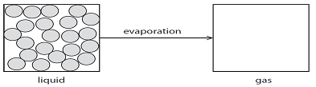
(a) Complete the diagram to show the arrangement of four particles in a gas. (1)

(b) Describe the movement of particles in a gas. (1)

(c) Explain why heating a liquid causes it to evaporate more quickly. (2)

2. Techniques used in the separation of mixtures include

A = crystallisation
B = filtration
C = fractional distillation
D = simple distillation

For each separation, select the most suitable technique, A, B, C or D, used to obtain the first named substance from the mixture. Each letter may be used once, more than once or not at all.

(a) Pure water from sea water =
(b) Ethanol from a mixture of ethanol and water =
(c) Calcium carbonate from a mixture of calcium carbonate and water =
(d) CuSO₄.5H₂O(s) from CuSO₄(aq) = (4)

(e) Sea water contains dissolved sodium chloride. The following pieces of laboratory apparatus can be used to make drinking water from sea water.
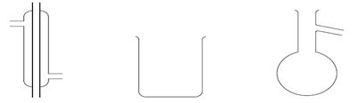
(i) Draw a labelled diagram to show how these pieces of apparatus can be assembled to do this. (3)

(ii) Name the technique used in this process. (1)

3. A teacher uses this apparatus to show the reaction between ammonia gas and hydrogen chloride gas to form ammonium chloride.
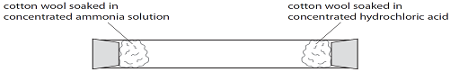

Concentrated ammonia solution gives off ammonia gas. Concentrated hydrochloric acid gives off hydrogen chloride gas. The reaction between the gases can be represented by this equation.

The diagram below shows the apparatus after a few minutes.
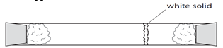

(a) Which process occurs when the gas particles move along the tube? (1)

(b) Name the white solid that forms in the tube. (1)

(c) Explain how the diagram shows which gas moves more quickly during the experiment. (1)

(d) The particles in a gas move very quickly. Why does it take a few minutes for the white gas to form?
(1)

4. This is a description of how the orange colouring can be extracted from rose petals.
- crush the petals using a pestle and mortar
- add the crushed petals to some ethanol in a beaker
- heat to about 60°C and stir to produce an orange solution
- separate the orange solution from the petals
(a) (i) Suggest why ethanol is used instead of water. (1)

(ii) Ethanol is a flammable liquid. Suggest how it could be heated safely. (1)

(iii) How could the orange solution be separated from the petals? (1)

(b) The orange colouring is analysed using chromatography and is found to consist of two different colours, red and yellow. The diagram shows the chromatography paper at the start of the experiment. Complete the diagram to show a possible result at the end of the experiment. (2)

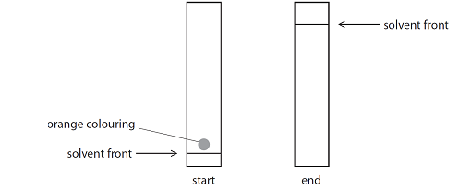

5.
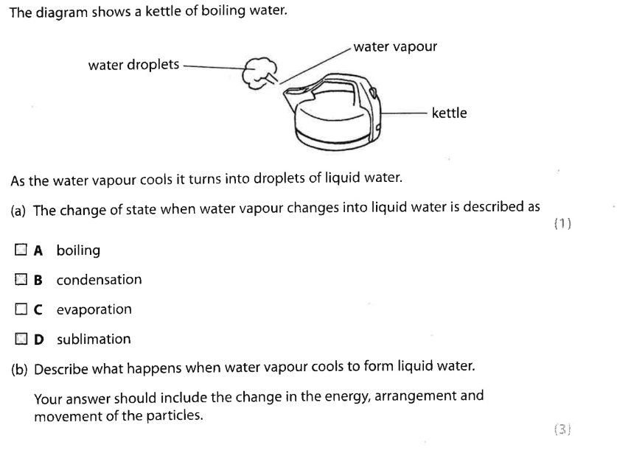
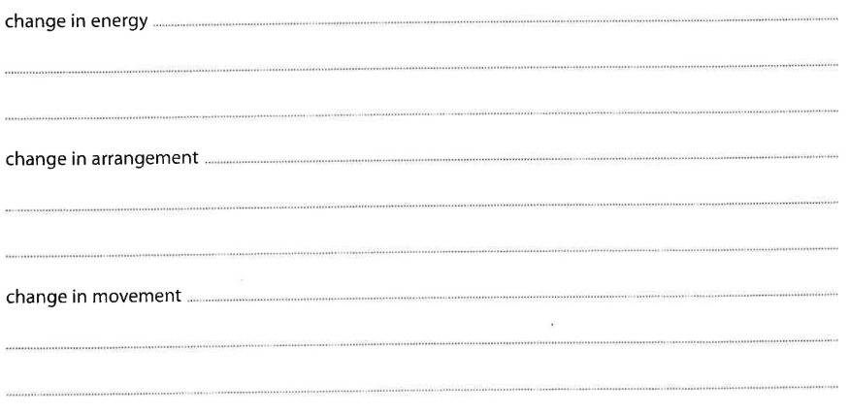
6.
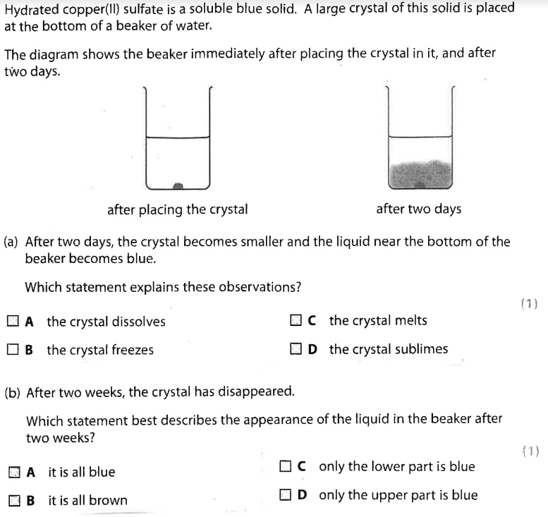

(c) Describe each of the following boxes as either ‘ element’, ‘compound’ or ‘mixture’.

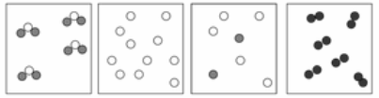
_______________ _______________ _______________ _______________

7.
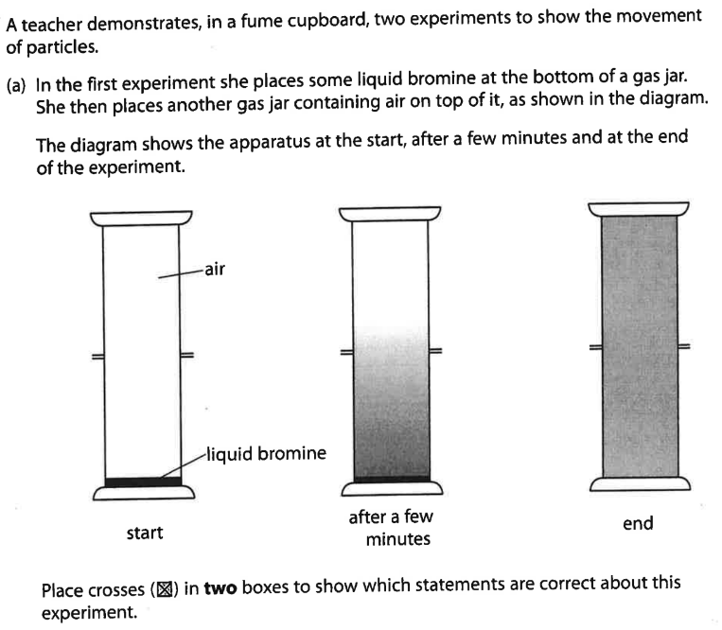
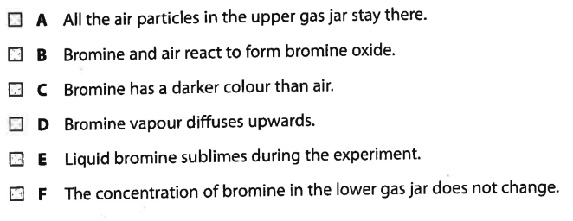

8.
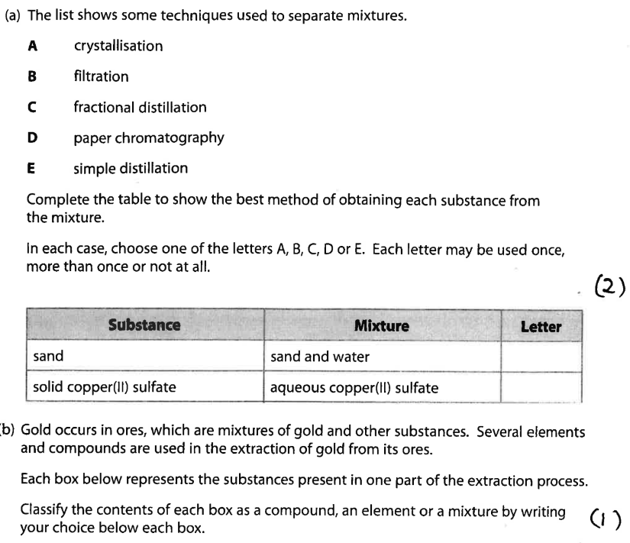
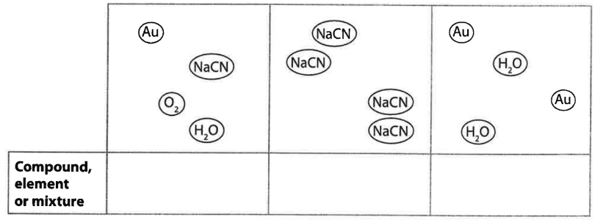

9.
Four Separate food dyes (C, D, E and F) and a mixture of food dyes (X) were investigated using paper chromatography. The diagram shows the apparatus used:
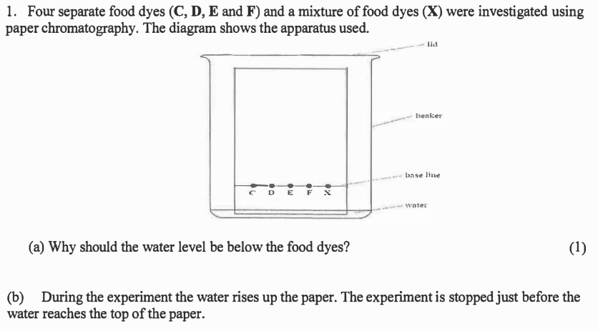
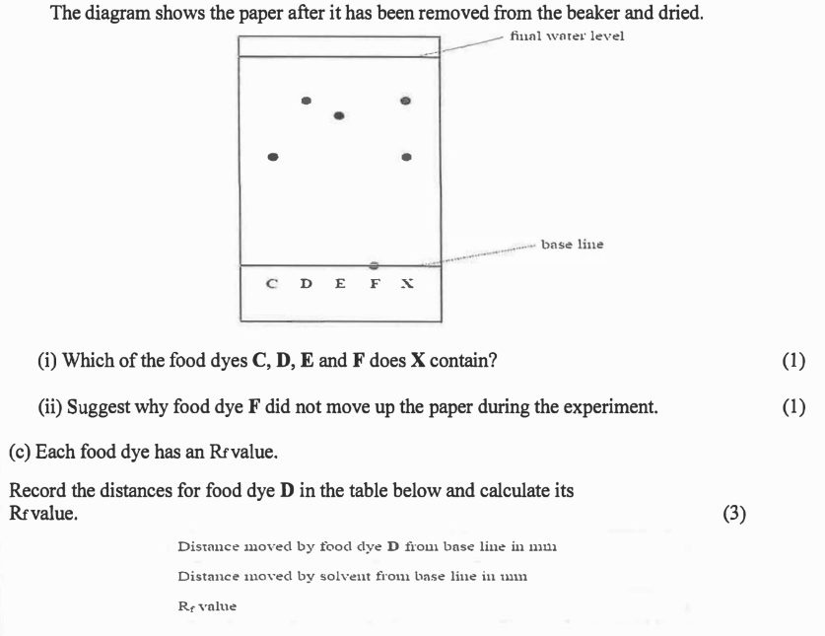

Distance moved by food dye D from base line in mm
Distance moved by solvent front from base line in mm
R_{f} value

Blank page for notes about anything from Unit 1

